CHANGES HISTORY
PIC | Date | Remarks
Ghaida | 2018.04.23 | Created

TOC
- Portfolio Assetallocation
- Portfolio Deposit
- Portfolio Company
- Simpi Assetallocation
- Simpi Deposit
- Simpi Company
- Simpi Rating
- Portfolio Rating
- Portfolio Currency
- Simpi Currency

Diagram ENTITY RELATIONSHIP

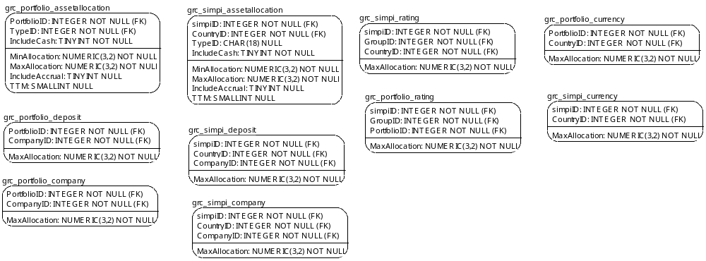

TABLE RELATIONSHIP
No | Table 1 | Table 2 | Type (1:1; 1:N; M:N) | Description

Name |  | grc_portfolio_assetallocation
Objective
No | Column |  | Type | Rule  (PK, FK, Key, NN, Unik, Index) | Description
1. | PortfolioID |  | Integer | FK
2. | TypeID |  | Integer | FK
3. | IncludeCash |  | TINYInteger | NN
4. | MinAllocation |  | Numeric(3,2) | NN
5. | MaxAllocation |  | Numeric(3,2) | NN
6. | TTM |  | TINYInteger | Null
7. | IncludeAccrual |  | SMALLInteger | Null

SAMPLE DATA
No | Column | Sample 1 | Sample 2 | Sample 3 | Sample 4
1. | PortfolioID | 51 | 51 | 51 | 53
2. | TypeID | 1 | 2 | 2 | 1
3. | IncludeCash | 0 | 0 | 1 | 0
4. | MinAllocation | 0.8 | 0 | 0.02 | 0.8
5. | MaxAllocation | 0.89 | 0.2 | 0.2 | 0.98
6. | TTM | 0 | 0 | 365 | 0
7. | IncludeAccrual | 0 | 0 | 0 | 0

Name |  | grc_portfolio_deposit
Objective
No | Column |  | Type | Rule  (PK, FK, Key, NN, Unik, Index) | Description
1. | PortfolioID |  | Integer | FK
2. | CompanyID |  | Integer | FK
3. | MaxAllocation |  | Numeric(3,2) | NN

SAMPLE DATA
No | Column | Sample 1 | Sample 2 | Sample 3 | Sample 4
1. | PortfolioID | 91 | 91 | 91 | 113
2. | CompanyID | 60 | 66 | 92 | 60
3. | MaxAllocation | 0.1 | 0.15 | 0.1 | 0.1

Name |  | grc_portfolio_company
Objective
No | Column |  | Type | Rule  (PK, FK, Key, NN, Unik, Index) | Description
1. | PortfolioID |  | Integer | FK
2. | CompanyID |  | Integer | FK
3. | MaxAllocation |  | Numeric(3,2) | NN

SAMPLE DATA
No | Column | Sample 1 | Sample 2 | Sample 3 | Sample 4
1. | PortfolioID | 91 | 91 | 113 | 113
2. | CompanyID | 92 | 468 | 60 | 64
3. | MaxAllocation | 0.1 | 0.1 | 0.1 | 0.1

Name |  | grc_simpi_assetallocation
Objective
No | Column |  | Type | Rule  (PK, FK, Key, NN, Unik, Index) | Description
1. | simpiID |  | Integer | FK
2. | CountryID |  | Integer | FK
3. | TypeID |  | Char(18) | Null
4. | IncludeCash |  | TINYInteger | NN
5. | MaxAllocation |  | Numeric(3,2) | NN
6. | TTM |  | SMALLInteger | Null
7. | IncludeAccrual |  | TINYInteger | Null
8. | MinAllocation |  | Numeric(3,2) | NN

SAMPLE DATA
No | Column | Sample 1 | Sample 2 | Sample 3 | Sample 4
1. | simpiID
2. | CountryID
3. | TypeID
4. | IncludeCash
5. | MaxAllocation
6. | TTM
7. | IncludeAccrual
8. | MinAllocation

Name |  | grc_simpi_deposit
Objective
No | Column |  | Type | Rule  (PK, FK, Key, NN, Unik, Index) | Description
1. | simpiID |  | Integer | FK
2. | CountryID |  | Integer | FK
3. | CompanyID |  | Integer | FK
4. | MaxAllocation |  | Numeric(3,2) | NN

SAMPLE DATA
No | Column | Sample 1 | Sample 2 | Sample 3 | Sample 4
1. | simpiID
2. | CountryID
3. | CompanyID
4. | MaxAllocation

Name |  | grc_simpi_company
Objective
No | Column |  | Type | Rule  (PK, FK, Key, NN, Unik, Index) | Description
1. | simpiID |  | Integer | FK
2. | CountryID |  | Integer | FK
3. | CompanyID |  | Integer | FK
4. | MaxAllocation |  | Numeric(3,2) | NN

SAMPLE DATA
No | Column | Sample 1 | Sample 2 | Sample 3 | Sample 4
1. | simpiID
2. | CountryID
3. | CompanyID
4. | MaxAllocation

Name |  | grc_simpi_rating
Objective
No | Column |  | Type | Rule  (PK, FK, Key, NN, Unik, Index) | Description
1. | simpiID |  | Integer | FK
2. | GroupID |  | Integer | FK
3. | CountryID |  | Integer | FK
4. | MaxAllocation |  | Numeric(3,2) | NN

SAMPLE DATA
No | Column | Sample 1 | Sample 2 | Sample 3 | Sample 4
1. | simpiID
2. | GroupID
3. | CountryID
4. | MaxAllocation

Name |  | grc_portfolio_rating
Objective
No | Column |  | Type | Rule  (PK, FK, Key, NN, Unik, Index) | Description
1. | simpiID |  | Integer | FK
2. | GroupID |  | Integer | FK
3. | PortfolioID |  | Integer | FK
4. | MaxAllocation |  | Numeric(3,2) | NN

SAMPLE DATA
No | Column | Sample 1 | Sample 2 | Sample 3 | Sample 4
1. | simpiID
2. | GroupID
3. | PortfolioID
4. | MaxAllocation

Name |  | grc_portfolio_currency
Objective
No | Column |  | Type | Rule  (PK, FK, Key, NN, Unik, Index) | Description
1. | PortfolioID |  | Integer | FK
2. | CountryID |  | Integer | FK
3. | MaxAllocation |  | Numeric(3,2) | NN

SAMPLE DATA
No | Column | Sample 1 | Sample 2 | Sample 3 | Sample 4
1. | PortfolioID
2. | CountryID
3. | MaxAllocation

Name |  | grc_simpi_currency
Objective
No | Column |  | Type | Rule  (PK, FK, Key, NN, Unik, Index) | Description
1. | simpiID |  | Integer | FK
2. | CountryID |  | Integer | FK
3. | MaxAllocation |  | Numeric(3,2) | NN

SAMPLE DATA
No | Column | Sample 1 | Sample 2 | Sample 3 | Sample 4
1. | simpiID
2. | CountryID
3. | MaxAllocation

